Opening a Bakery near Boston, Massachusetts

By Stéphane D.

# Introduction

One of my dream business opportunities would be to open a bakery. I live in the Cambridge/ Somerville area (right across the river from Boston, Massachusetts) and these neighborhoods have experienced an increase in appeal over the last ten years. While it was nearly impossible to find quality bread ten years ago, many high-end bakeries have since opened, and the competition for high end is now steep.

The purpose of this project is to find the perfect location for opening a bakery. It must have a proximity to existing bakeries; however, it cannot be too close in order to avoid direct competition. The bakery will also have to be within reasonable distance of the subway system (the MBTA "T"). Also, the bakery will need to be in an up-and-coming neighborhood. A map will be used to summarize and display the results.

# Data

The Foursquare API will be used to localize already existing bakeries. With the help of the geocoder, the subway stations locations will be obtained. Finally, using data from the City of Cambridge, the attractive areas of the city will be fetched and displayed on a map.

# Methodology

Using the Folium package, the above data will be displayed using markers with a specific radius. The radii will be obtained using trial and error until real-life results are obtained.

First, let’s display the principal subway (“T”) stations in the area on a map:

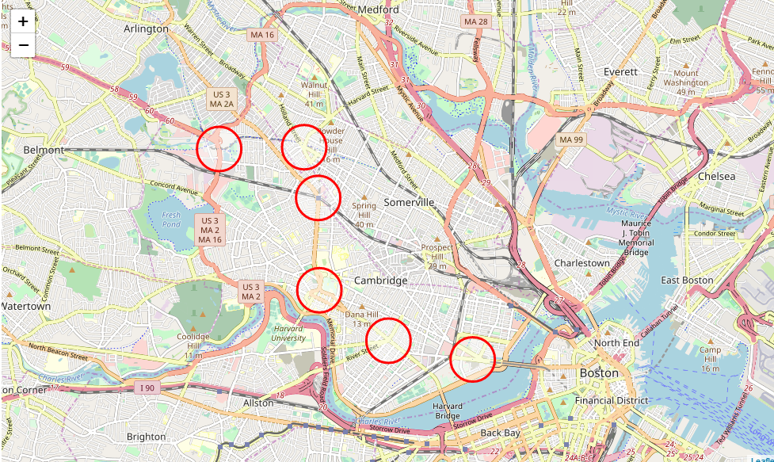

A radius of 400 meters was deemed appropriate (subway stations are quite spread out in Boston compared to other major cities). This is the radius inside which it would be optimum to install a new business.

Then, for each subway station, the list of the bakeries in the vicinity are obtained using the Foursquare API. The “venue search” commands are issues for bakeries using the ‘categoryID’ for bakeries (this turned out to be more accurate than just searching for ‘bakery’). The results are shown below:

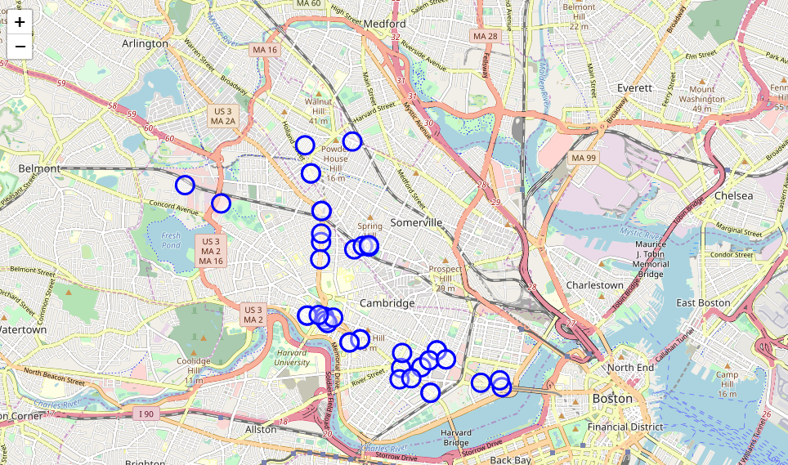

A radius of 150 meters was deemed appropriate around a bakery. This is the radius inside which we should NOT open any new bakery business because it’s too close to an existing one.

Finally, I wanted to obtain data about real estate prices in the area but after hours of search, all I could find was the 2012 property tax data of the City of Cambridge, which had a lot of missing data, including the square footage of most units. I decided to go another route and display the “attractiveness” of neighborhood (<https://data.cambridgema.gov/Planning/Envision-Cambridge-Mobile-Engagement-Feedback/sx7w-cut7/data>). After importing the data, I have drawn lightly shaded circles to display every positive comment about the city at the recorded location. It resulted in the following map:

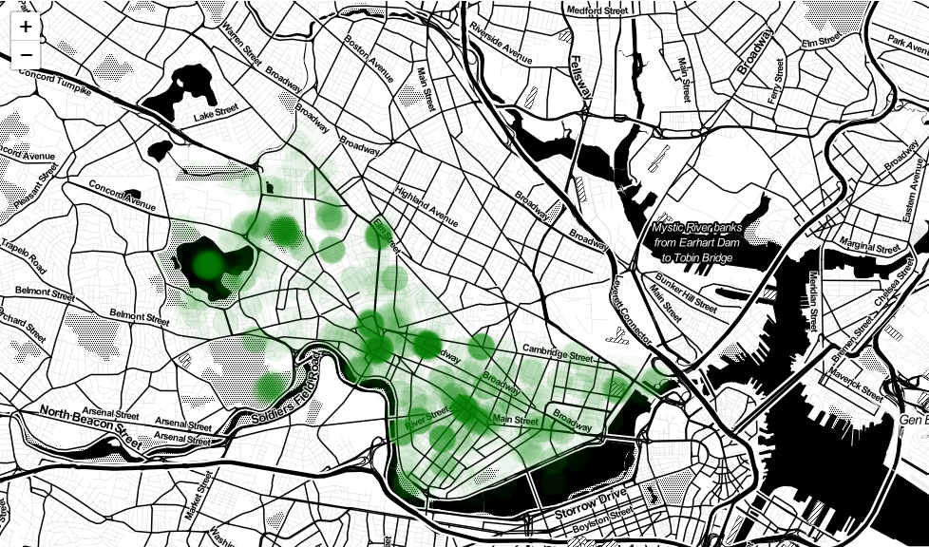

# Results

Combining all the data from the previous Section, the resulting map is:

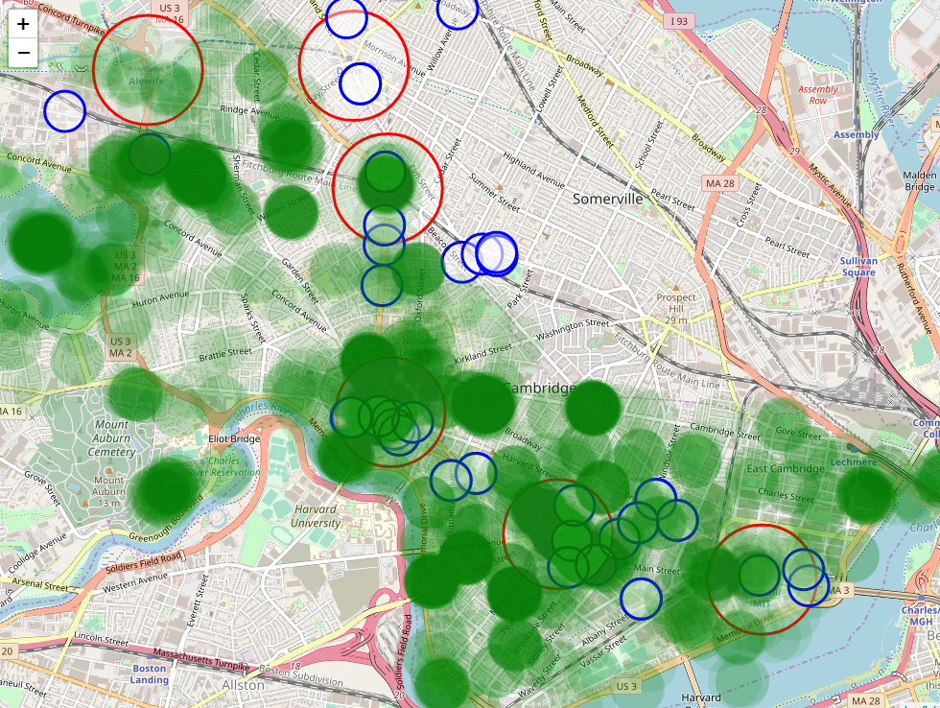

A

F

E

D

C

B

A

It can be seen that area A is a good candidate with no existing bakery in the vicinity of the subway. However, the attractiveness of the area is not the greatest.

Area B does not have the attractivity data (it’s technically a different town), but it is nevertheless a charming neighborhood. However, there are already two bakeries in the vicinity. There could be potential for a third.

Area C has potential for areas far enough from existing bakeries, it’s close to an MBTA stop, and overall, is considered to be an attractive neighborhood of Cambridge.

Areas D, E, F are very popular, but unsurprisingly, these spots have a lot of existing businesses. Within this stretch of Cambridge, area F would be the best choice.

# Discussion

The above Section provides some feedback on where a good location for a bakery would be. However, there are two main caveats to this analysis:

* It would make sense to see what business spaces are for lease first, and then cross-check the map to see if the location meets the other criteria.
* This analysis only considers a few parameters, but many others are at play:
  + Proximity to bus lines
  + Wealth of the neighborhood
  + Safety of the neighborhood
  + Foot traffic at that location
  + Cost of retail space
  + And many more!

# Conclusion

This report presents a simplified analysis of a Boston neighborhood and the potential location for opening a new bakery (think hot croissants and baguettes!). The report mixes the data from various sources to attempt to judge of the quality of a specific address. This would be a great starting point for someone actively looking to open a business in an up-and-coming area of a growing city!